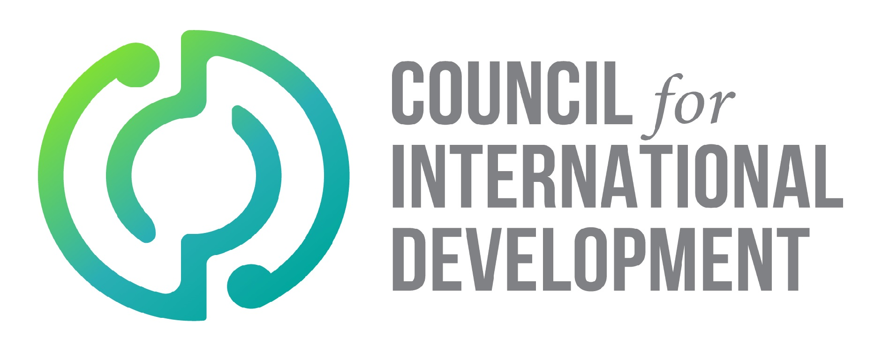

Note: A Child Protection Policy should be tailored according to organisation’s size, operations and risk to children. This template can be changed according to organisational context. This template can assist with understanding some of the policy requirements for CID Code of Conduct mandatory obligation B.3.4 Protection of children.
[Organisation]
Child Protection Policy
This policy will be reviewed triennially, and details recorded as below.
Version | Date | Author/s | Approved by | Review Date | Comments

- Purpose
[ORGANISATION] values its duty of care to protect the children who are impacted by our work (directly or indirectly) and to act in their best interests. [ORGANISATION] is committed to the protection of children from harm, abuse and exploitation as expected in the United Nations’ Declaration on the Rights of the Child. This policy also takes into consideration best practice and requirements of the Vulnerable Children Act 2014 in keeping with New Zealand legislation. [ORGANISATION] will regularly review our Child Protection Policy and procedures, which are outlined below.
- Scope
This policy is intended to apply to all [ORGANISATION] activities. This policy is applicable to all [ORGANISATION] personnel. This policy also extends to [ORGANISATION] partners and associates.
- Roles and Responsibilities
It is the responsibility of the Management Team to ensure that [ORGANISATION] takes every precaution to protect the children and young people we serve and encounter during the course of our work.

- Definitions
Child protection includes prevention of and response to any risk or actual instance of physical, sexual and emotional harm, exploitation or abuse, whether done directly to a child or with communications/technology.
A child is any person under age 18.
Child abuse is defined in The Children, Young Persons and their Families Act 1989, as "…the harming (whether physically, emotionally, sexually), ill-treatment, abuse, neglect, or deprivation of any child or young person.”
- Recruitment
Recruitment involves the hiring of staff, volunteers, consultants and suppliers in New Zealand and overseas to work for [ORGANISATION] and partners. [ORGANISATION] seeks to minimise child abuse risk through every step of the hiring process by including well-advertised child protection commitments and thorough background vetting systems of potential hires (including the use of police checks for those in regular contact with children).
- Education, training and awareness
[ORGANISATION] will ensure all stakeholders are aware of and uphold the Child Protection Policy. Education around the Child Protection Policy will be provided to all staff through inductions and regular trainings, so staff remain informed of current best practice.
- Interactions with children
[ORGANISATION] acknowledges the significance of protecting children while in [ORGANISATION]’s care. Those tasked with guardianship of children while working for [ORGANISATION] will receive child-friendly training, resources and support to effectively and safely accept care.
[ORGANISATION] will not for any reason publish (for fundraising or promotional purposes) text, photographs or other forms of information that may cause harm to a child or represent a child in an inappropriate or illegal (harmful, abusive or exploitative) manner. Representation of a child in photo or text from [ORGANISATION’s] data image bank and from other official [ORGANISATION] sources will be consistent with [ORGANISATION ’s] usage guidelines. Please refer to the [ORGANISATION's] Photography Guidelines for more information and for [ORGANISATION] approved consent forms.
- Misconduct
[ORGANISATION] will promptly investigate all reported actual or suspected breaches of this policy and, where grounds are found to exist, will take appropriate corrective measures and/or report the matter to the relevant authorities. [ORGANISATION] reserves the right to initiate appropriate action up to and including employment/contractual termination for staff or other representatives, or for volunteers/interns, to sever the volunteer relationship.
- Procedures with Regard to International Programmes and Implementing Partners
Verification of due diligence and risk management on the part of delivery partners. This includes working with our partners to ensure they have developed a child protection policy, providing regular trainings/capacity building for our partners and monitoring their child protection measures through site visits.
Programme-level Child Protection Risk Management. As part of the programme design, review and proposal approval process, programmes staff will also conduct a review which highlights the level of risk of child harm, abuse or exploitation.
Visits to [ORGANISATION] Programmes coordinated by [ORGANISATION]. We will clearly articulate our commitments to child protection and ensure those in contact with children are under the management of [ORGANISATION] and closely monitored.
- Incident Reporting
It is mandatory for all (AGENCY) personnel and associates to report any witnessed, suspected or alleged incidents of child abuse or any breach of the CPP and/or COC. These concerns may relate to a child or a staff member involved in the organisation or a concern about a child or person/s outside of the organisation’s programs. [ORGANISATION] strives towards incident reporting which is child friendly. If you do have a concern you should immediately follow [ORGANISATION’s] child abuse reporting procedures.
Who should report?
All (AGENCY) staff and associates including people in the community and partner organisations.
What should be reported?
Any disclosure, concern or allegation from a child, community member, staff or associate regarding the safety, abuse or exploitation of a child (this includes actual, suspected, or risk of abuse or harm to a child)
Any observation or concerning behaviour exhibited by an (AGENCY) staff, volunteer or other associate that breaches the (AGENCY) Code of Conduct for Working with Children.
When to report?
Child abuse concerns should be raised immediately.
Who to report to?
Overseas: Child abuse reports should be made to the line manager or Country Director. If this is not possible reports can be made directly to the New Zealand-based Child Protection Officer (CPO)
In New Zealand: Child abuse reports should be made to the CPO or the CEO.
[Include contact details for CPO]
How should it be reported?
Verbally and by completing the ORGANISATION child abuse incident reporting sheet
What will happen next?
The CEO and/or Country Director in consultation the CPO will discuss the allegations and then decide upon the next step. This will involve one or more of the following:
Interviewing the person/persons who made the allegations and/or other witnesses to gather more information with which to make a decision about the allegation;
Reporting to local police and or child protection authority when it is suspected or becomes clear that a crime has been committed, or if require assistance to determine the appropriate course of action;
- Reporting to local child protection services as necessary
- Handling the concern internally if it is not a criminal matter
- No further action taken
- Providing support to all stakeholders (including reporter) as necessary
All incidents that involve sexual or physical abuse should be raised at the next scheduled Management meeting. Details regarding the child and the case should be strictly de-identified.
Management Team members would consider the incident report and reflect on whether any change to organisation policy, procedures and protocol is required.

